BENCHILL PRIMARY

NEWSLETTER
CHRISTMAS
2022

Dear Parents/Carers

It is hard to believe that we are at the end of the first full term. It has been a very busy term for the children and staff – and it has been wonderful to see everyone coming together again in school.

Everyone in school has worked so hard this term, so it is no wonder both staff and children are tired. The progress the children have made show us that it is all worthwhile, with success being reflected in results right across the school. Staff and children have done a fantastic job, and I would like to thank them all for the determination and resilience they always show.

AUTUMN TERM

It’s been a busy term across all year groups. Year 5 learnt a lot about the Anglo Saxons during their exciting visit from archaeologists as well as a performance for Road Safety Week.
The whole school took part in Black History Month in October and Anti-bullying week in November. As part of our school’s Peace Mala journey, Year 3 have worked alongside Reverend Malika creating their own Peace Malas and learning more about the Peace Mala bracelets. Year 4, Year 2 and Nursery have also been learning about some of the key festivals from the different religions.
DO NOT FORGET: School closes for the Christmas holiday at 12.30 this Thursday 23rd December 2022. Please pick up your children promptly.

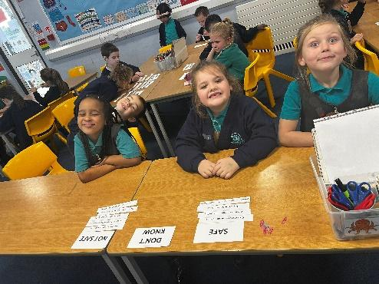
The children have done a great job at completing their 100 Things this term. Activities included, being a fantastic friend, learning a new sport and running through leaves!

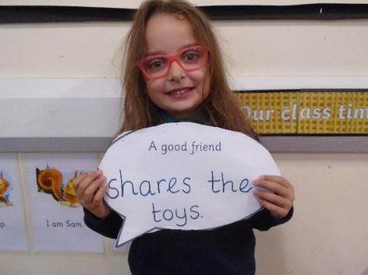

We have also raised money for two charities this term. Our coffee and cake sale raised £200 for St. Anne’s Hospice and our World Cup themed Children in Need day raised £180. Thankyou for all your support and contributions!

CHRISTMAS

Everyone has had great fun in the lead up to Christmas. Thank-you again for all your donations and support at the Christmas Fair. We raised £1,300 which will go back into school to buy some books. The children put all their energy into their Christmas performances last week and enjoyed Christmas dinner and Christmas jumper day.

Thursday 22nd December is Christmas party day! The children can come to school in their party clothes at the normal time and then the party will officially start at 11am.

OTHER NEWS

- From Monday 9th January, the price of Breakfast Club will increase from 30p to 80p a day. School will now cover the cost of this club as the charitable support and funding we used to receive has ended.

- We would also like to ask children in Year 3 – 6 to start bringing in their own healthy snack for breaktime from January, if they would like to. This could be fruit, vegetable sticks or dried fruit. Crisps, chocolate, breakfast bars or biscuits will not be allowed.

- As a school, we will also be moving to paperless communications with parents & carers. This means that from January, all letters with regards to events, school trips and general communication will be communicated via text or email. We’ve been working hard to ensure everyone’s contact details are up to date. If any of your contact details do change, please let us know as soon as possible.

- There is a wealth of information and advice available to everyone on the cost of living crisis as we all understand this is something that is affecting everyone. Manchester City Council have set up a website at Manchester.gov.uk/helpinghands and a free helpline on 0800 023 2692 open 09:00-4:30 Monday-Friday if anyone needs any help.

ATTENDANCE

I cannot finish a term without having to mention our attendance. With the winter months, we do see more illness in children and we do not want children to attend if they are poorly, but if in doubt, please send them in. We do phone parents to collect children if we think they are too unwell to be in school. Please feel free to phone our Parent Support worker, Miss Icely, or the school office, if you need any advice on this.

We are all looking forward to the start of another new year, working together with you to make sure your children enjoy school and make good progress.

During the holidays, there are some very important things than you can do to help them succeed. Take the time to listen to your child read and make sure that they are reading every day for at least 15 minutes. This can make an enormous difference to the range of vocabulary your child feels confident to use. There are some great suggestions for how to support your child on the school website. Encourage good social skills and help them to make good choices and order for themselves if you go out to eat. All these things will help your child have greater success when they come back in January.

HEADTEACHER’S MESSAGE

Last but not least, I must remind everyone that school will reopen for children on Monday 9th January 2023, with classroom doors open from 8.40 a.m.

All that remains for me to do is to say a great big ‘thank you’ to all of you for your continued support. May all of you have a “Merry Christmas,” a peaceful, joyous and healthy time with your loved ones.

Merry Christmas

Mrs Eken
Headteacher

